**1. Selecting a Tileset for your map**

When you create a new map, Tileset selection window will appear:



These all are original Dune 2000 tilesets that come with the game. You can get or create a custom tileset and use it to make maps with different terrain graphics than the original Dune 2000 provides.

All original Dune 2000 tilesets look graphically same, and you almost cannot recognize in-game which tileset you are currently playing on. The sand, rock and cliffs look the same in every tileset. The difference between tilesets are the **tileset-specific special tiles**, such as infantry-only rocks, various decorations such as ruins of buildings buried in sand, crashed planes, but the most notable are bridges and ice.

Here you can see example of tileset-specific tiles. Below is BLOXBGBS with its typical bridge and stairs, and then BLOXBASE with building ruins in sand (both examples occupy same position in tileset):

BLOXBGBS:

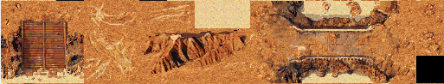

BLOXBASE:

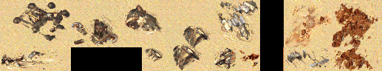

**You cannot combine special tiles from more tilesets in a single map**, so you need to choose just one tileset that fits the best the theme and setting in your map.

The best to start with is to create a map with one of the tilesets, then on Terrain tab click **Open tileset** button and look what current tileset offers. You can change tileset at any time from menu.

**2. Terrain editing: Paint mode**

When you create a map, you start off with a blank map full of sand. You want to put some terrain on it, such as rock, dunes, spice etc. This is what Paint mode is here for.

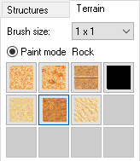

Select a **Terrain type** you want to paint. For most tilesets, these basic terrain types are available (on the second row):

- Sand (spice can be placed on it and sandworm can move on it)

- Rock (buildings can be placed on)

- Dunes (units slow down on it)

On the first row, 4 special terrain types are:

- Thin spice (one tile can be harvested 2 times)

- Thick spice (one tile can be harvested 2 times then turns thin spice)

- Concrete (for decoration only, does not work as real concrete you build in game)

- Void (black tile, could be used to create empty parts of map)

Now you can paint some terrain on map with mouse. You can select **Brush size** from 1*1 to 4*4 if you want to fill bigger size of terrain at once. Or, you can quickly change the brush size by scrolling mouse wheel up/down while holding Shift key.

You can also take advantage of the **Flood-fill area feature** to automatically fill a bigger enclosed area. Just paint a border of your area and make sure it is well enclosed:

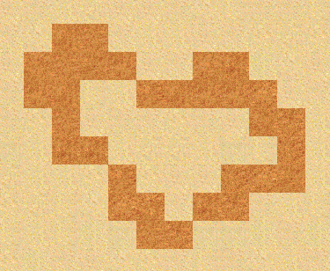

Then double-click with mouse inside this area. Area will get filled automatically:

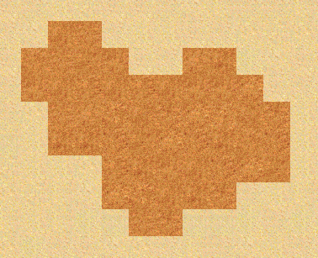

Now use **Auto-smooth edges feature**, which can save you plenty of time from manually placing rock edge tiles around your rock area. Just **Shift-click** (click with left mouse button while holding Shift key) on any edge rock tile, and watch the editor doing all hard work for you within a millisecond. Voila:

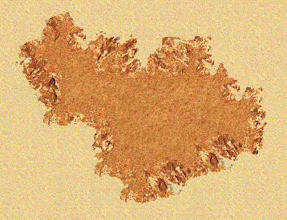

The same function works on Dunes as well.

Be aware, that the auto-smooth edges algorithm works in **counterclockwise direction**. It will walk around the area from the tile you click on in this direction and replace tiles with edge tiles, until it reaches the starting point again, or it reaches any obstacle or border of the map. So when painting for example a rock area on the border of map, remember to shift-click at the tile closest to the map edge on the proper side.

If you want to modify (i.e. extend) an existing area with already smoothed edges, just repaint that part with rock and shift-click again on the proper starting point, and the edge will link together with existing edge automatically.

There is **Restrict painting** feature which will allow you paint specific terrain type only on terrain where it should be logically possible. For example spice and dunes can be placed only on sand, and concrete only on rock. It can be turned off in Settings menu.

**3. Terrain editing: Block mode**

In Block mode you can place “blocks”. For example **cliffs** are composed of various blocks placed next to each other, forming a continuous border between rock and sand. Also, various decorations and bridges are made up from blocks too.

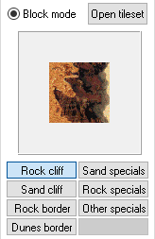

You have two possibilities how to select a block:

1. Click **Open tileset** button and you will see the complete tileset. Here you can manually select any block of tiles you want. This is not very convenient, as it is quite hard to find the exact block you want.

2. Use a **Block preset** from a particular **Block preset group**.

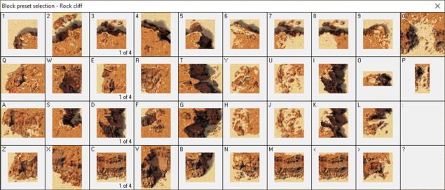

On the **Block preset selection window** you will see all presets from current group **arranged in logical order**, so it will be very easy to select the block you want. To open this window, either double-click on any of 8 block preset group buttons, or click into the rectangle where current block is drawn, or press Space.

Select a block by clicking on it. Some of the blocks have multiple variants, right-click on such block to select the next variant.

If you want to keep this window open (and for example place it on the second monitor), turn off “Hide preset window” in Settings menu.

Notice that every block has its **keyboard shortcut**. You can quickly select that block by just pressing respective key on keyboard (1,2,3,Q,W,E,R,…) without even opening the preset window. Press the same key multiple times to select next variant.

This can significantly speed up mapping for you, once you remember each block position on keyboard, you can draw cliffs and other terrain really fast!

More tips:

- To display keyboard keys on the preset window, press middle mouse button on it.

- You can select a block directly from map by pressing middle button on map. Block of the current brush size will get selected. You can also press Shift + 1-8 keys to select particular brush size.

- You can use arrows on numeric keyboard (Num 2, 4, 6, 8) to move block around map. This is useful when you want to move block beyond left and top border of map, which is normally not possible. Use Num 5 to place block.

- Press F1 – F4 keys to quickly select block preset group. Press the same key second time to select the second group.

- Press ` key (the key under Esc) to quickly switch to Paint mode. The respective terrain type related to current block preset group will get selected.

- There are lot of various keyboard shortcuts to quickly select different modes. Use the built-in help from Help menu (“Key Shortcuts”, “Mouse actions”) to see them all.

**4. Select mode**

Select mode is useful, when you want to select a bigger part of map, and duplicate it or move it around. This way you can also easily transfer portions of map into different map, and it is even possible to transfer them between multiple instances of editor using Copy + Paste feature.



To start a selection, switch to **Select mode** (or press Shift+C). Then make a rectangle selection on your map. Then editor will switch to Block mode, and you will be able to place the selected block at any place in your map.

To easily and quickly start a selection without switching into Select mode manually, you can be in any other mode, hold **Ctrl key** and by clicking into map you automatically start a selection.

With the **Structures** checkbox, you can select whether you want **buildings and units** to be included in your selection, or you want to select terrain only. With the third checkbox state you can select building and units only (without terrain), which can be useful to copy a base layout.

You can also make **precise non-rectangular** selection of specific terrain type you want. Expand the **Area:** combo box and select terrain type you want to select. Then only tiles of specific terrain type will get selected, the other tiles will remain blank.

There is also **Cut** mode available, which means, the area you select will get erased (replaced by sand). This is useful when you want to move around specific part of map. To cut selected area, hold **Shift key** while making a selection.

In order to transfer a selected block between maps or between multiple instances of editor, press **Ctrl+C** to copy current block to clipboard. Then, in the other editor window, press **Ctrl+V** to retrieve the block from clipboard.

**5. Structures mode**

In Structures mode you can place **buildings, units** and other miscellaneous objects such as worm spawners or spice blooms.

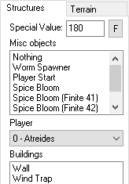

Placing buildings and units is pretty straightforward and does not require any more explanation. Use left button to place a building/unit, right button to erase it, and middle button to copy existing structure from map (you must click on top-left corner of a building). The “Player” combo box value can be quickly selected with Num 0 – Num 7 keys.

Under **Misc objects** list you can find following objects:

- **Worm Spawner**: a point where sandworm will spawn in a map after some time after starting a map. It is mandatory to have at least one worm spawner in a map, without it game would crash. In multiplayer maps it is required to have 3 worm spawners.

- **Player Start**: a point where a player will start in multiplayer map (MCV will get spawned at this point). It is required to have exactly 8 of them in a multiplayer map. You should not place player starts in campaign missions at all.

- **Spice Bloom**: a point where a spice bloom will appear when spice gets harvested from this point. Spice bloom will grow and then regenerate spice. You should place spice blooms in the middle of a spice field. The spice bloom will generate **infinitely**, so spice cannot be depleted at all.

- **Spice Bloom (Finite X)**: this kind of spice bloom will generate only **limited number of times** and then will disappear completely. The first type of finite spice bloom will generate about 7 times, the second about 17 times, the other types will generate more times (it was not counted how many it is).

Note that there is overall limitation of about 30 spice blooms in a map, if you place more, those above 30 will not generate in game.

Each type of structure (building, unit, misc object) has a specific **Special Value**, which is just an internal representation of such object in game’s map format. For standard use, you do not need to bother about special values at all. (You can place some specific special value for some advanced modding purposes.)

There is **Find structure feature**, which will find selected object in a map by centering view on it. Press the “F” button or Ctrl+F to find selected type of structure.

You cannot place buildings and units in multiplayer maps. If you place some, the game will ignore them and they will not appear in your map. (You can achieve having pre-placed buildings in multiplayer maps only with use of advanced modding and hacks.)

**6. Campaign Mission vs. Multiplayer Map**

As you might already know, in Dune 2000 there are two kinds of maps: campaign missions and multiplayer maps (which are playable from i.e. Practice mode). In both cases, you will have **a .MAP file**, which contains information about terrain and structures. The main difference is, that **a campaign mission has its counterpart .MIS file** (i.e. for “A1V1.MAP” it is “_A1V1.MIS”) which contains additional mission data (starting money, tech level, allegiance among sides, AI etc.) and scripted events. To edit mission data and events, go to “Mission settings” and “Events and conditions” under “Mission” menu. Multiplayer maps do not have own .MIS file, it’s just a terrain.

When you create a new map in the editor, a campaign mission is created by default. If you want to switch it to a multiplayer map, click on “Unassign .mis file” option in Mission menu. In such case, “Mission settings” and “Events and conditions” menu options will become unavailable and you will not be able to use Test map feature. If a .MIS file is already saved, you will need to delete it from disk. Oppositely, to switch a map into campaign mission, click on “Assign .mis file” and a .MIS file will get created.

Most of settings (i.e. starting money, tech level) in multiplayer maps are driven by manual in-game configuration you provide before you launch a multiplayer game. However, some data for multiplayer maps are taken from “_PRAC.MIS” file which is located in “Data\Maps” game folder. Allegiance is taken from this file, and the first player AI (Atreides) is used for all AI players. So you can edit “_PRAC.MIS” file to alter allegiance and AI, however, you cannot edit this file directly in editor. You will need to create a dummy “PRAC.MAP” file and open it first.

Note that information about tileset is stored inside “_PRAC.MIS” as well. If you want to make a multiplayer map with different tileset than BLOXBGBS, you will need to change tileset in “_PRAC.MIS”.

For more detailed information about how to edit events and conditions, look into “D2k Event and Condition Manual” and for more information about how to edit AI, look into “D2k AI Manual”.

**7. Event markers**

Each campaign mission has some **scripted events**, such as **reinforcements**, harvester replacement (once all of your harvesters get destroyed you get a spare one) and others. When you open an existing mission from game’s Missions folder, or create any events in your mission, you will see **event markers** on your map.

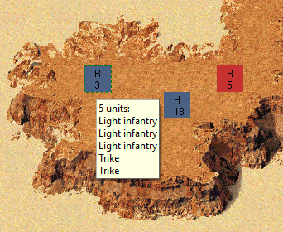

Event markers appear as colored rectangles on map. The color means which side the event is related to (i.e. blue = Atreides, red = Harkonnen), the letter means type of event, and number means number of event.

There are these possible event types:

R = Reinforcement (carryall will enter map and drop some units)

H = Harvester replacement (reinforcement that brings only harvester)

S = Unit spawn (units are spawned on this place, this is used mainly to spawn enemy units in enemy bases that wander around base and protect it)

M = Reveal map (tiles in specific radius around it get revealed based on scripted event)

T = Tile revealed (this is actually a condition, once your unit gets near this tile and reveals it, some other event will get triggered)

In Structures mode you can move around event markers by dragging them with mouse, which will actually modify the events.

By double clicking on event marker you will open this event directly in Events and Conditions editor, where you can for example edit the units.

You can disable event markers in Settings menu.